**Table of Contents**

|  |
| --- |
|  |
| **01** |
|  |
|  |
|  |
| **02** |
|  |
|  |
|  |
| **03** |
|  |
|  |
|  |
| **04** |
|  |
|  |
|  |
| **05** |
|  |
|  |
|  |
| **06** |
|  |
|  |
|  |
| **07** |
|  |
|  |
|  |
| **08** |
|  |

Hospital Management System - An Overview

How does it Work?

Minimum System Requirement

How will this be helpful to my institution?

Features and Functions

Security and Quality

**Video Tutorial**

[**https://www.youtube.com/watch?v=RiPYOC7o1sg**](https://www.youtube.com/watch?v=RiPYOC7o1sg)

**Live Demo**

**http://hms-demo.jaysonsarino.com/**

**Hospital Management System - An Overview**

HMS is designed for medical practitioners and health-related institutions to assistant them in storing and keeping track of all correlated information such as patient medical records, admission/discharge reports, pharmaceutical management, billing & report generation and more. This new system will take care of the long processes and tedium work involved in tracing and retrieving records thus improving efficiency in your organization's internal system.

HMS Program aimed to meet these following objectives:

• **Increased Staff Productivity**

HMS systemized information distribution will able each members to retrieve medical records fast and relevant. This in return leads to quick attention in serving your patient needs.

• **Better Data Handling**

All information will be stored in a database for centralization. Security features are applied to protect data from theft and malware attack. User-restrictions will also be applied, only information relevant to a staff shall be displayed.

• **Reduced Admin Workload**

Generate reports and retrieve information in just few clicks. HMS will provide ease in doing these normally tedious task.

• **Paperless, Eco-Friendly System**

Manage and distribute data online. Reducing the need of cutting down a tree for the purpose of

using a paper.

• **Monitor Anytime Anywhere**

Being an online application - HMS can be accessed literally anytime anywhere provided you have an access to the internet. It's "Responsive" capability makes it even advanced as you will be able to access the interface using tablets and smart phones. Making "people-on-the-go" like you still part of the loop.

**How does it work?**

HMS works by setting up an online website. This website will then be configured according to your requirement. Since this is online-based, a "User-Role" shall be created to restrict unauthorized access to your system.

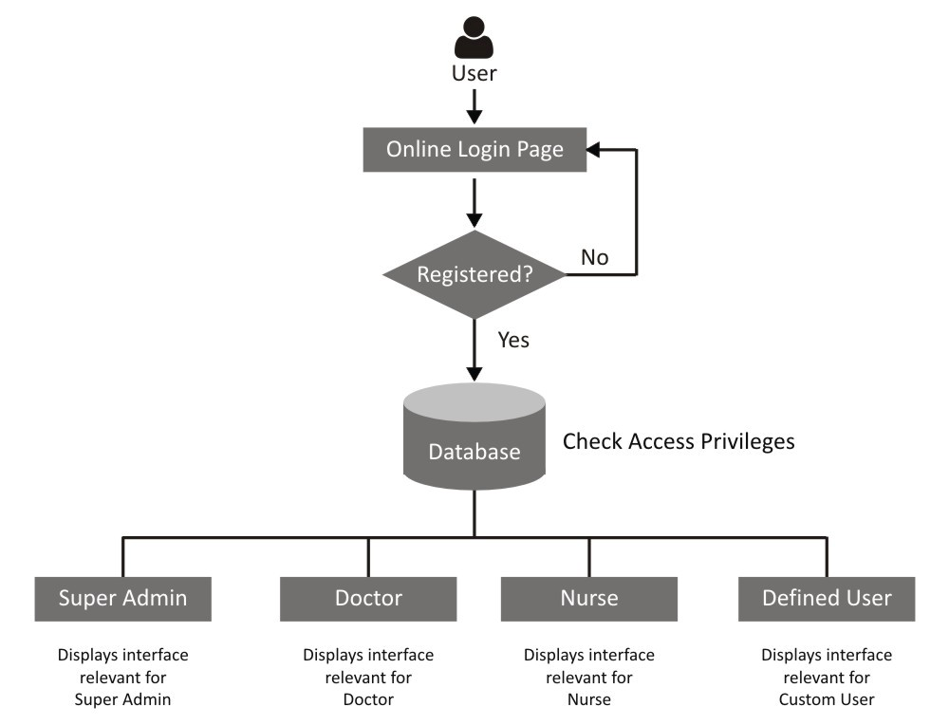

**Minimum System Requirement**

HMS needs to meet this minimum system requirement on location;

• 1 Unit Desktop Computer

• With adequate storage capacity

• Running on either XP, Windows 7 or Windows 8 Operating System

• A Broadband / DSL Internet Connection.

This unit will act as your system front-end. The more computers you have per department, the better this will serve you.

**How will this be helpful to my institution?**

Healthcare Management System (HMS) will provide ease and comfort to you and your staffs daily routine task. Common problems listed below will be reduced in no time;

• Slow admission process

• Overcrowding

• Immediate data retrieval problem

• Storage problem

• Slow or delayed data updates

• No security - records can be ruined, burned or stolen anytime

• Error-prone due to manual calculations

• Tedious preparation of billing and report

**Features and Functions**

The following are an overview of HMS’ features and functionalities:

• **Registration Feature**

Patient demographics are captured in this module. At the time of patient registration, the system generates a unique MRN (Medical Registration Number). Subsequently appointments can be generated / scheduled using MRN.

✓ Pre-Registration

✓ OP Visit Registration

✓ IP Visit Registration

✓ OP-IP Conversion

✓ Admission Profile

✓ Follow-up information for OP and IP visits

✓ Mandatory “Document Reference” Uploading

✓ Appointment Notification

• **In-Patient Management**

✓ Advance Booking Feature

✓ Quick Admission Form Generation

✓ Clinical Service Details

✓ Comprehensive Laboratory Details

✓ Vital Sign Report Summary

✓ Intake/Output Records

✓ Nurse Progress Notes

✓ Room Transfers

✓ Bed Side Procedures

✓ Operation Theater

✓ Corporate Bill Management

✓ Detailed “Daily Bill” Management

✓ Discharge Summary

✓ Quick Discharge Certificate Issuance

• **Out-Patient Management**

✓ Consultant On-Duty

✓ Patients' History

✓ Diagnosis Details

✓ Daily/Weekly/Monthly Schedule Summary

✓ Investigation/Treatment Summary

✓ Clinical Service Details

✓ Nurse Progress Notes

✓ Surgery Scheduling Details

✓ OP Medical Observation

✓ Vital Sign Report Summary

✓ Discharge Notification

✓ Discharge Summary

• **Billing Management**

✓ One-Click Billing / Quick Payment Option

✓ Print Invoice and Receipts

✓ Insurance and Sponsor Bills

✓ Discounts and Rate Changes

• **Billing Quotations**

✓ Pharmaceutical Management

✓ Medicine Management

✓ Drug Category Management

✓ Drug Name Management

✓ Inventory Management

• **EMR View**

✓ Mandatory “Document Reference” Uploading

✓ Clinical Service Details - Discharge Summaries, Admission Profile etc.

✓ Diagnostic Reports, Procedures and Services

✓ Prescriptions and Case Sheets

• **Administration**

✓ Role-Based Access Control

✓ Master Settings and Configurations

✓ User Management - User Creation and Update.

✓ Actions and Module Designations.

• **System Security and Software Management**

✓ User-Role Management

✓ Access Control Rights (who has the right to access the Software)

✓ Password Integrity (Password Encryption)

✓ Complete Data Backup

• **MIS Report**

✓ Patient Master List Report

✓ Individual Patient Reports

✓ Out-Patient Reports

✓ Admitted Patient Reports

✓ Discharged Patient Reports

✓ Medical Record Reports

✓ EMR Reports

✓ Daily Sales Report

**Security and Quality**

Healthcare Management System **(HMS)** is developed using advanced framework ensuring stability over long period of its use. While HMS is programmed for accuracy and efficiency, humans operating behind are still prone to errors. Every user should realize that at command, HMS can and will delete any stored data. Therefore assigning restrictions and / or “confirming” prior to execution of command should be part of every user’s daily routine-check.

As important it is to you, we also guarantee non-disclosure of any records pertaining to any individual stored in the program. Data Backup Feature is also been anticipated to ensure record safe-keeping. Just

Schedule an appointment and we’ll accommodate a secure backup.